Riphah International University
I-14 Main Campus
Faculty of Computing

Semester Project

Mr. Junaid Khan

Daniyal Asghar
53731
Daniyal Saeed
53937

Climate Change & Weather Data Warehouse

Problem Statement
Climate change is one of the most critical global challenges today, but environmental data is often scattered across multiple sources and formats.
As a result:
- Long-term temperature trends are difficult to analyze
- Rainfall patterns and seasonal shifts are not clearly identified
- Pollution data comparison across regions is complex
- Extreme weather impacts are not easily studied

Introduction
Climate change has significant impacts on the environment, including rising temperatures, irregular rainfall, pollution, and extreme weather events.
This project uses the dataset: Global Climate Change & Extreme Weather Impact (Kaggle), which contains data on temperature, CO2 emissions, rainfall, and climate risks.
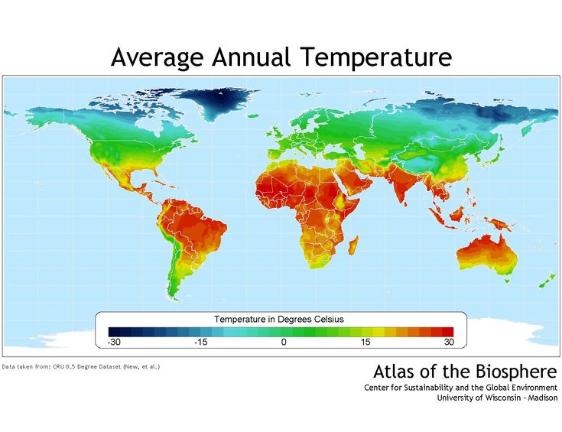

The aim of this project is to build a centralized Data Warehouse to analyze climate data and identify patterns, trends, and risks.

Objectives
1) Integrate environmental data into a structured warehouse
2) Analyze long-term climate trends
3) Study impact of extreme weather events
4) Provide insights using dashboards and reports

Dataset Description
The dataset includes temperature change, CO2 emissions, rainfall variation, flood and drought risks, and air quality data.
It provides a comprehensive view of climate indicators across regions.

https://www.kaggle.com/datasets/algozee/climate-cahnge?select=Beginner_Climate_Change_Dataset_20_Features_1200_Rows.csv

Scope of the Project
• Data Integration: Import and clean dataset using ETL
• Temperature Trends Analysis: Study global warming patterns
• Rainfall Patterns: Identify flood and drought areas
• Pollution Analysis: Compare AQI and CO2 levels
• Seasonal Changes: Detect unusual weather shifts
• Extreme Weather Analysis: Analyze floods, heatwaves, droughts
• Visualization: Dashboards using Power BI or Tableau

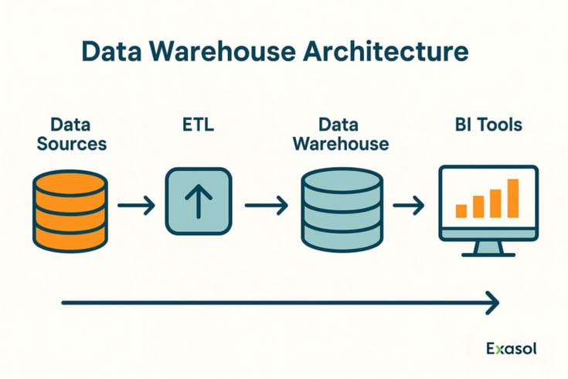

Tools and Technologies
Database: PostgreSQL / Snowflake
ETL: Python (Pandas, NumPy)
Visualization: Power BI / Tableau
Programming: Python
Data Source: Kaggle Climate Dataset

Expected Outcomes
1) Structured climate data warehouse
2) Interactive dashboards
3) Insights into temperature and pollution trends
4) Identification of high-risk regions

Conclusion
The Climate Change & Weather Data Warehouse will provide a centralized system for analyzing environmental data. It will help in understanding climate patterns and supporting better decision-making.

Submitted By
DANIYAL ASGHAR
DANIYAL SAEED

